Year / Semester: IV/ VII
Data Science Fundamentals (OCS353)
1. Define Data Science.
Data Science is an interdisciplinary field that uses scientific methods, statistics, programming, and machine learning to extract useful information and insights from data.
2. What is data preparation?
Data preparation is the process of collecting, cleaning, transforming, and organizing raw data before analysis.
3. List the two types of NumPy Universal Functions (UFuncs).
- Unary UFuncs: operate on a single input array, e.g., np.sqrt().
- Binary UFuncs: operate on two input arrays or operands, e.g., np.add().
- 4. Differentiate Python lists and NumPy arrays.
Python list | NumPy array
Can store mixed data types | Usually stores one data type
General-purpose container | Designed for numerical computation
Arithmetic often requires loops | Supports vectorized arithmetic
Less efficient for large numerical data | Often more memory-efficient for numerical data

5. Define Machine Learning.
Machine Learning is a branch of artificial intelligence that enables computers to learn patterns from data and make predictions or decisions without explicitly programming every rule.
6. Mention applications of Machine Learning.
- Image and speech recognition
- Medical diagnosis
- Fraud detection
- Recommendation systems
- Weather forecasting
- Self-driving systems

7. Differentiate plot() and scatter().
plot() | scatter()
Commonly draws lines connecting data points | Displays individual points
Useful for trends and time series | Useful for relationships between variables
Example: plt.plot(x, y) | Example: plt.scatter(x, y)

8. List the interfaces of Matplotlib.
- Pyplot interface (matplotlib.pyplot)
- Object-oriented interface (Figure and Axes objects)
- 9. Mention tools used for high-performance data processing.
- Examples include NumPy, pandas, Dask, Apache Spark, and distributed-computing frameworks. The question paper does not specify a fixed list.
- 10. Define streaming data.
- Streaming data is data generated and processed continuously in real time or near real time, such as sensor readings, online transactions, and website activity.

9. Mention tools used for high-performance data processing.
Examples include NumPy, pandas, Dask, Apache Spark, and distributed-computing frameworks. The question paper does not specify a fixed list.
10. Define streaming data.
Streaming data is data generated and processed continuously in real time or near real time, such as sensor readings, online transactions, and website activity.

Q11(a). Examine the different facets/categories of data and explain the challenges involved in processing them.
Important points to write:
- Structured data: Organized into rows and columns, such as spreadsheets and relational databases.
- Semi-structured data: Has some organizational structure but no rigid table format, such as JSON and XML.
- Unstructured data: Text, images, audio, and video.
- Numerical data: Quantitative values, including discrete and continuous data.
- Categorical data: Values representing groups or labels.
Challenges in data processing:
- Large data volume.
- High speed of data generation.
- Different data formats and sources.
- Missing and inconsistent values.
- Duplicate and noisy data.
- Data privacy and security.
- High computational and storage requirements.
- Integrating data from different sources.

(B). Describe the complete Data Science Process with a neat diagram.
1. Define the problem
2. Collect data
3. Prepare and clean data
4. Explore and visualize data
5. Build a model
6. Evaluate results
7. Communicate and deploy
Explain each stage:
- Problem definition: Identify the objective and research question.
- Data collection: Gather information from databases, files, surveys, or sensors.
- Data preparation: Handle missing values, duplicates, errors, and inconsistent formats.
- Exploratory Data Analysis (EDA): Use statistics and visualizations to understand patterns.
- Model building: Apply statistical methods or machine-learning algorithms.
- Evaluation: Measure accuracy and determine whether the model meets its objectives.
- Communication and deployment: Present findings and put useful models into practice.
12.(A)Explain different operations that can be performed on NumPy arrays.

Operation | Example
Create an array | np.array([1, 2, 3])
Indexing | a[0]
Slicing | a[1:3]
Reshaping | a.reshape(3, 1)
Arithmetic | a + b, a * b
Aggregation | np.sum(a), np.mean(a)
Sorting | np.sort(a)
Filtering | a[a > 2]
Transpose | a.T for a 2-D array
Broadcasting | Arithmetic between compatible shapes
Also prepare array dimensions (ndim), shape (shape), size (size), and data type (dtype).

Q12(b). Combining datasets using concatenation, append and joins.

- Concatenation: Combines arrays along an existing axis using np.concatenate().
- Append: Adds values to an array using np.append(). It returns a new array rather than changing the original.
- Join: Combines datasets based on a common key or relationship, typically using pandas.

Example:
import numpy as np

a = np.array([1, 2])
b = np.array([3, 4])

print(np.concatenate((a, b)))
print(np.append(a, 5))
OUTPUT:
[1 2 3 4]
[1 2 5]

For dataset joins, study inner join, left join, right join, and outer join, with a small table example showing a common key.

Q13(a). Learning techniques in Unsupervised Learning
Unsupervised learning discovers patterns in data without predefined target labels.
Main techniques:
- Clustering: Groups similar data points.
  - Examples: K-means, hierarchical clustering, DBSCAN.
- Dimensionality reduction: Reduces the number of features while retaining important information.
  - Example: Principal Component Analysis (PCA).
- Association rule learning: Finds relationships between items.
  - Example: Market-basket analysis.
- Anomaly detection: Identifies unusual observations.
- Density estimation: Estimates how data points are distributed.
Applications include customer segmentation, image analysis, and discovering patterns in large datasets.
Q13(b).K-means clustering for lossy image compression
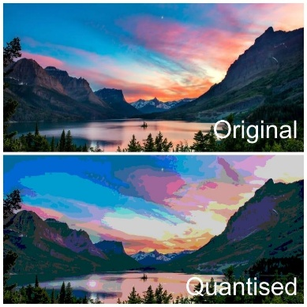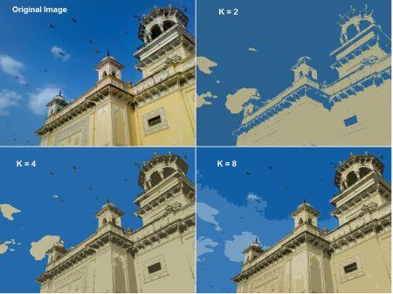
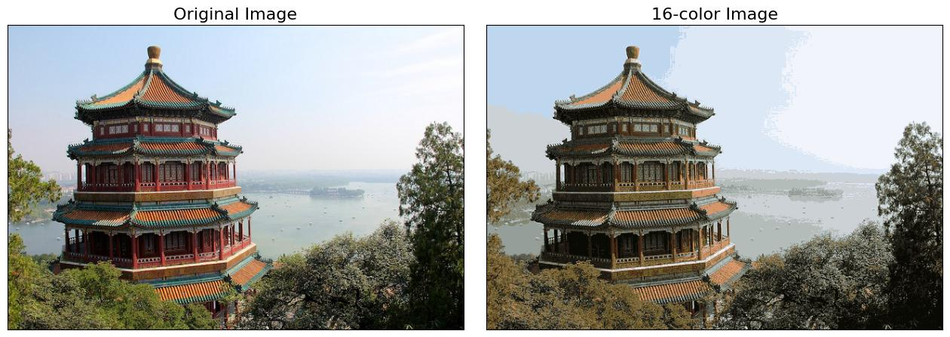
Key points:
- Represent each pixel using its colour components, such as RGB values.
- Choose the number of clusters, \(K\).
- Initialize \(K\) cluster centroids.
- Assign each pixel to its nearest centroid.
- Recalculate each centroid using the mean colour of its assigned pixels.
- Repeat the assignment and update steps until convergence.
- Replace every pixel's original colour with its cluster-centroid colour.
- Store the reduced colour palette and pixel-to-cluster assignments.
Why is it lossy? Different original colours are replaced with the same representative colour, so some image information is lost.
Advantages: Fewer colours, potentially smaller storage requirements, and simpler colour representation.
Limitation: Image quality may decrease, and actual file-size savings depend on the encoding format.

Q14(a). Explain density plots and contour plots with suitable examples.
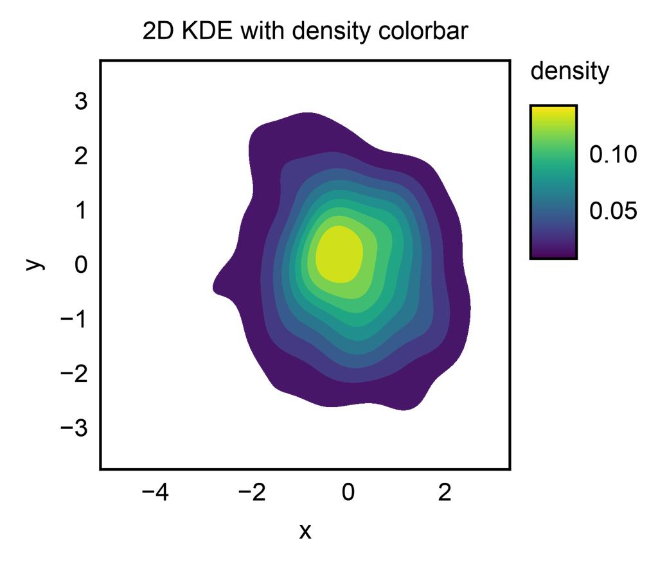
Density plot
Represents the concentration or estimated probability density of observations. Darker or more intense regions often indicate higher density.
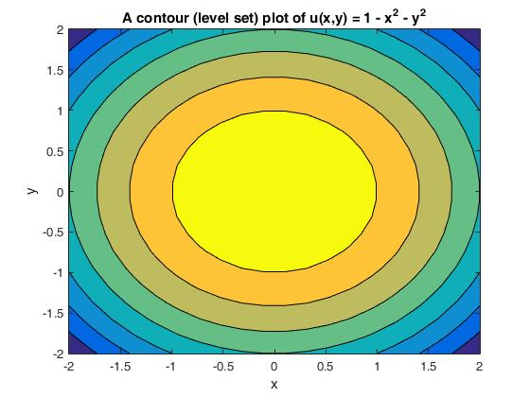
Contour plot
Uses lines connecting points with equal values of a function. It is useful for visualizing a three-dimensional surface on a two-dimensional plane.
Points to include:
- Definition of each plot.
- How each plot represents values.
- Suitable examples.
- Applications in scientific analysis.
- A labelled diagram.
Python examples:
import matplotlib.pyplot as plt
import numpy as np

x = np.linspace(-3, 3, 100)
y = np.linspace(-3, 3, 100)
X, Y = np.meshgrid(x, y)
Z = np.exp(-(X**2 + Y**2))

plt.contour(X, Y, Z)
plt.show()

plt.contourf(X, Y, Z)
plt.show()

Q14(b). Describe cylindrical projection and explain how the globe can be projected onto a 2-D surface to plot three Indian cities.
Key points:
- A cylindrical projection maps points from the globe onto a cylinder.
- The cylinder is mathematically transformed into a flat, two-dimensional map.
- Latitude and longitude are used to locate geographical points.
- Longitude is commonly represented horizontally, while latitude is represented vertically in a simple equirectangular projection.
- The map may distort distances, areas, and shapes, especially at high latitudes.
- Cities can be plotted using their geographic coordinates.
Example cities and approximate coordinates:
City | Latitude | Longitude
Chennai | 13.08° N | 80.27° E
Mumbai | 19.08° N | 72.88° E
Delhi | 28.61° N | 77.21° E
Use a labelled cylinder-to-flat-map sketch and mark the three cities on the resulting 2-D map. The above cities are illustrative examples; the question does not prescribe specific cities.
Q15(a). Explain the complete Data Science Process for a Reddit classification case study, from defining the research question to model building and presentation.
Structure your answer as a case study:
- Research question: Define what Reddit content should be classified and into which categories.
- Data collection: Gather relevant Reddit posts or comments, subject to access permissions.
- Data preparation: Remove duplicates, handle missing fields, clean text, and process labels.
- Exploratory analysis: Examine category frequencies, text lengths, and word distributions.
- Feature extraction: Convert text into numerical features using methods such as TF-IDF.
- Model building: Train an appropriate classifier, such as Naive Bayes, logistic regression, or a suitable text model.
- Model evaluation: Use a held-out test set and metrics such as precision, recall, F1-score, and accuracy.
- Presentation: Communicate findings, limitations, errors, and possible improvements.
Important: Mention class imbalance, privacy, biased labels, and the need to avoid data leakage.
Q15(b). Describe the importance of data-structure selection in large-data algorithms and explain sparse data structures with suitable examples.
Why data-structure selection matters:
- Memory consumption.
- Execution speed.
- Searching and updating efficiency.
- Scalability.
- Suitability for the algorithm and data format.
Common structures include arrays, lists, hash tables, trees, graphs, and sparse matrices.
Sparse data structures store data efficiently when most values are zero or absent.
Examples:
- Sparse matrices for scientific calculations.
- Compressed Sparse Row (CSR) for efficient row-based matrix operations.
- Compressed Sparse Column (CSC) for column-based operations.
- Dictionary-based representations for sparse vectors.
Example: A matrix with 1,000,000 positions but only 1,000 non-zero values can waste considerable space if every zero is stored. A sparse representation stores the non-zero values and their positions instead.
Applications include recommendation systems, text processing, graph algorithms, and scientific computing.

Q16(a)Given website-visit tuples, use split-apply-combine operations to find the website with maximum duration.
The paper asks you to use website-visit tuples to find the website with the maximum duration. The exact input tuples are not provided in the question text, so the final website cannot be calculated without them.
The method is:
1. Split
Group visit records according to the website.
2. Apply
Calculate the total visit duration for each website.
3. Combine
Compare the totals and select the website with the highest duration.
Python example:
from collections import defaultdictvisits = [ ("A", 10), ("B", 20), ("A", 15), ("C", 8), ("B", 5)]totals = defaultdict(int)for website, duration in visits: totals[website] += durationwebsite = max(totals, key=totals.get)print("Website:", website)print("Total duration:", totals[website])
Output:
Website: B
Total duration: 25
This is an illustrative example, not the answer to any missing tuples in your paper.
Q16(b). Construct and apply a tree data structure for social-network analysis
Important points to study:
- Define a tree as a hierarchical, connected structure consisting of nodes and edges, with no cycles.
- Explain the root, parent, child, leaf, and subtree.
- Draw a labelled tree.
- Explain how a tree can represent a hierarchical relationship, such as organizational roles or community categories.
- Describe node insertion, searching, and traversal.
- Explain breadth-first and depth-first traversal where relevant.
- Discuss applications such as hierarchy exploration and organizing social-network information.
- State limitations: ordinary trees cannot directly represent arbitrary friendships between many users, because social networks commonly contain cycles and multiple connections.
Important distinction: A graph is usually the more natural representation of a general social network. A tree can be used for a hierarchical view or a spanning tree of that network.
Example:
Community
Group A
Member 1
Group B
Member 2
This diagram illustrates a hierarchy, not every friendship connection in a social network.

